Integrate Zscaler with Identity Providers (IdPs) such as Azure AD, Okta, and Active Directory for seamless authentication and authorization.

Integrate Zscaler with Identity Providers (IdPs) such as Azure AD, Okta, and Active Directory for seamless authentication and authorization.

List of Team members:

S. No. | Name | College Name | Contact
1 | Zeenathunnisha.S | Sri Ramakrishna College of Arts and Science for Women | srcw2322k162@srcw.ac.in
2 | Yazhini.N | Sri Ramakrishna College of Arts and Science for Women | srcw2322k160@srcw.ac.in
3 | Lathi Priya.S | Sri Ramakrishna College of Arts and Science for Women | srcw2322k161@srcw.ac.in
4 | Sayana Suresh Lal | Sri Ramakrishna College of Arts and Science for Women | srcw2322k163@srcw.ac.in

Project Details
Title:
Integrate Zscaler with Identity Providers (IdPs) such as Azure AD, Okta, and Active Directory for seamless authentication and authorization.
Introduction:
In modern organizations, secure access to applications and data is essential, especially with the increasing number of remote users and cloud-based services. Integrating Zscaler with Identity Providers (IdPs) such as Microsoft Azure Active Directory, Okta, and Active Directory helps organizations implement strong authentication and authorization mechanisms while ensuring seamless user access. An Identity Provider (IdP) is a system that manages user identities and verifies authentication credentials when users attempt to access applications or services. These systems store and manage user information such as usernames, passwords, roles, and permissions. By integrating Zscaler with these identity platforms, organizations can enforce identity-based security policies instead of relying solely on network-based access.
Zscaler uses a Zero Trust security model, which means no user or device is automatically trusted. Every access request must be authenticated and verified before granting access to applications or network resources. When integrated with IdPs like Microsoft Azure Active Directory, Okta, or Active Directory, Zscaler can authenticate users through Single Sign-On (SSO). This allows users to log in once using their corporate credentials and securely access multiple applications without repeatedly entering login information. Through this integration, Zscaler can obtain important identity attributes such as user roles, group memberships, and organizational policies from the Identity Provider. These attributes help administrators create granular access control policies. For example, employees from different departments can be granted access only to the applications relevant to their roles, while sensitive systems can be restricted to authorized personnel.
Additionally, integrating Zscaler with identity providers enhances security monitoring and threat prevention. If a user's credentials are compromised or suspicious activity is detected, the identity provider can immediately revoke access or require additional authentication methods such as Multi-Factor Authentication (MFA). Zscaler can then enforce these authentication requirements before allowing access to applications. Another advantage of this integration is centralized identity management. Administrators can manage user accounts, permissions, and authentication policies from a single identity platform, reducing complexity and administrative effort. This also ensures consistent security policies across all cloud and on-premise applications.
Overall, integrating Zscaler with Identity Providers like Microsoft Azure Active Directory, Okta, and Active Directory improves organizational security by implementing identity-based access control, reducing dependency on traditional VPN solutions, and enabling secure access to applications from any location. This approach helps organizations protect sensitive data while providing a smooth and secure user experience.

Abstract
The increasing use of cloud services and remote work environments has created a strong need for secure and centralized identity management systems. This project focuses on the integration of Zscaler, a cloud-based security platform, with Identity Providers (IdPs) such as Microsoft Azure Active Directory to enhance secure user authentication and access control. The integration enables organizations to implement a modern security approach where user identity becomes the key factor in granting access to internet resources and enterprise applications.
The project demonstrates how Zscaler can be connected with Azure Active Directory using secure authentication protocols such as SAML and OpenID Connect. Through this integration, Azure AD acts as the Identity Provider responsible for authenticating users, while Zscaler functions as the Service Provider that enforces security policies and controls user access to web services and applications.
By implementing this integration, organizations can achieve features such as Single Sign-On (SSO), centralized identity management, and improved security through multi-factor authentication. The system also supports modern cybersecurity frameworks like Zero Trust Architecture, ensuring that only authenticated and authorized users are allowed to access network resources. This approach reduces security risks, simplifies user management, and improves the overall user experience.
The main objective of this project is to study the architecture, configuration process, and security benefits of integrating Zscaler with Azure Active Directory. The project highlights how this integration can help organizations strengthen their cloud security infrastructure while maintaining efficient and seamless access to digital resources.

Use Case Scenarios:
Use Case Scenarios 1:Secure Remote Employee Internet Access
An employee working from home needs secure access to the internet for daily work activities. Instead of directly connecting to the internet, the employee’s traffic is routed through Zscaler. The employee authenticates using corporate credentials through Azure AD, which verifies their identity and applies security policies before allowing internet access.
Output:
- User identity verified: Employee_Group via Azure AD
- Secure authentication: Single Sign-On (SSO) enabled
- Security policy applied: Web filtering and malware inspection enabled
- Access granted: Internet access based on employee role
- Additional protection: Suspicious or malicious websites automatically blocked

Use Case Scenario 2: Secure Access to Cloud Applications
A finance department employee needs to access a cloud-based accounting application. When the employee attempts to log in, authentication is handled through Azure AD. Once the identity is verified, Zscaler allows secure access to the cloud application while inspecting traffic for potential threats.
Output:
- User identity verified: Finance_Department_Group
- Authentication method: Azure AD Single Sign-On
- Access granted: Limited to authorized financial applications
- Security enforcement: Data loss prevention (DLP) policies applied
- Threat protection: Traffic inspected for malware or suspicious activity

Use Case Scenario 3: Third-Party Vendor Access to Internal Application
A third-party vendor needs temporary access to a specific internal web application used for system maintenance. Instead of providing full network access, Zscaler restricts the vendor to only the required application. Authentication is performed using Azure AD, ensuring the vendor identity is verified.

Output:
- User identity verified: Vendor_User via Azure AD
- Access restriction: Limited to Maintenance_Application_Server
- Security enforcement: Time-based access policy enabled
- Network protection: No access to other internal resources
- Monitoring: All user activity logged for security auditing

Use Case Scenario 4: Secure Student Access to Educational Resources
A student accessing online learning materials from home needs secure access to the institution’s learning portal. The authentication request is redirected to Azure AD, where the student logs in using institutional credentials. Zscaler then allows access only to approved educational resources.
Output:
- User identity verified: Student_Group via Azure AD
- Access allowed: Learning Management System (LMS) portal
- Security enforcement: Web filtering policies applied
- Restricted access: Blocked from administrative or staff resources
- Monitoring: Access activity recorded for security and compliance

Use Case Scenario 5: Administrator Access to Sensitive Systems
A system administrator needs to access critical internal servers for maintenance. Since the request involves sensitive infrastructure, Azure AD requires Multi-Factor Authentication before granting access. Zscaler ensures that the administrator can only access specific administrative systems.
Output:
- User identity verified: System_Admin_Group
- Security enforcement: Multi-Factor Authentication required
- Access granted: Limited to Infrastructure_Management_Server
- Context-aware policy: Access allowed only from approved devices
- Security monitoring: Administrative activity logged and monit

Stage – 1
Title:
Integrate Zscaler with Identity Providers (IdPs) such as Azure AD, Okta, and Active Directory for seamless authentication and authorization.
Overview:
Integrating Zscaler with an Identity Provider (IdP) like Microsoft Azure Active Directory (Azure AD) enables secure user authentication and centralized identity management for cloud applications and internet access. This integration is commonly implemented using Single Sign-On (SSO) and identity federation protocols such as SAML or OAuth.
Zscaler is a cloud-based security platform that provides secure web gateway, cloud firewall, and zero-trust network access. By integrating it with Azure AD, organizations can authenticate users through their existing identity management system while enforcing security policies for internet and application access. This approach improves security, simplifies user management, and enhances the overall user experience.
In this integration model, Azure AD acts as the Identity Provider, responsible for verifying user identities and providing authentication tokens. Zscaler acts as the Service Provider, allowing access only after the user is successfully authenticated by Azure AD. When a user attempts to access the internet or an application through Zscaler, the system redirects the authentication request to Azure AD. After successful authentication, Azure AD sends a security assertion back to Zscaler, granting the user secure access according to predefined policies.
This integration provides several advantages, including centralized user authentication, improved security through identity-based access control, reduced password management issues through SSO, and easier policy enforcement. It also allows organizations to apply conditional access policies, multi-factor authentication, and role-based access control using Azure AD.
Overall, integrating Zscaler with Azure AD helps organizations implement a Zero Trust security architecture, ensuring that only authenticated and authorized users can access network resources while maintaining strong protection against unauthorized access and cyber threats.

S. No. | Name | College Name | Contact
1 | Zeenathunnisha.S | Sri Ramakrishna College of Arts and Science for Women | srcw2322k162@srcw.ac.in
2 | Yazhini.N | Sri Ramakrishna College of Arts and Science for Women | srcw2322k160@srcw.ac.in
3 | Lathi Priya.S | Sri Ramakrishna College of Arts and Science for Women | srcw2322k161@srcw.ac.in
4 | Sayana Suresh Lal | Sri Ramakrishna College of Arts and Science for Women | srcw2322k163@srcw.ac.in

Integrate Zscaler with Identity Providers (IdPs) such as Azure AD

List the team members:

List of Vulnerability table:

S.No. | Category Name | Vulnerability Name | CWE - No
1 | Broken Access Control | Improper Authorization | CWE - 285
2 | Security Misconfiguration | Sensitive Cookie Without 'Http Only' Flag | CWE - 1004
3 | Software Supply Chain Failures | Use of Unmaintained Third-Party Components | CWE - 1104
4 | Cryptographic Failures | Insufficient Entropy | CWE - 331
5 | Injection | Improper Control of Generation of Code ('Code Injection') | CWE - 94
6 | Insecure Design | Inconsistent Interpretation of HTTP Requests ('HTTP Request Smuggling') | CWE - 444
7 | Authentication Failures | Authentication Bypass by Assumed-Immutable Data | CWE - 302
8 | Software or Data Integrity Failures | Improper Export of Android Application Components | CWE - 926
9 | Security Logging and Alerting Failures | Insufficient Logging | CWE - 778
10 | Mishandling of Exceptional Conditions | Improper Cleanup on Thrown Exception | CWE - 460

REPORT

1.
Vulnerability Name: Improper Authorization
CWE: CWE - 285
OWASP Category: A01:2025 Broken Access Control
Description: Improper Authorization (CWE-285) is a security vulnerability that occurs when an application fails to properly verify whether a user has permission to perform a specific action or access certain resources. In a secure system, after a user is authenticated, the application must check their authorization level (roles or permissions) before allowing access to sensitive functions or data. When this authorization check is missing, weak, or incorrectly implemented, unauthorized users may gain access to restricted features such as administrative panels, confidential data, or system configuration settings. This can allow attackers or normal users with limited privileges to perform actions they are not permitted to do.
For example, if a web application allows a normal user to directly access an admin URL (like /admin/dashboard) without verifying their role, the system becomes vulnerable to Improper Authorization. Attackers can exploit this flaw by manipulating URLs, parameters, or API requests to access protected resources. This vulnerability can lead to serious security risks such as data leakage, privilege escalation, unauthorized data modification, and system compromise. Proper role-based access control (RBAC), permission validation, and secure coding practices are necessary to prevent this vulnerability.
Business impact: The vulnerability CWE-285: Improper Authorization occurs when an application fails to properly verify whether a user has permission to access certain resources or perform specific actions. Attackers can exploit this flaw by manipulating URLs, parameters, or API requests to access restricted pages such as administrative panels or other users’ data. This can lead to the exposure of sensitive information including personal user details, financial data, internal business documents, and system configurations. The business impact can be severe, resulting in data breaches, unauthorized data modification, financial losses, regulatory penalties, and damage to the organization’s reputation. In critical cases, attackers may gain elevated privileges and compromise the entire system.
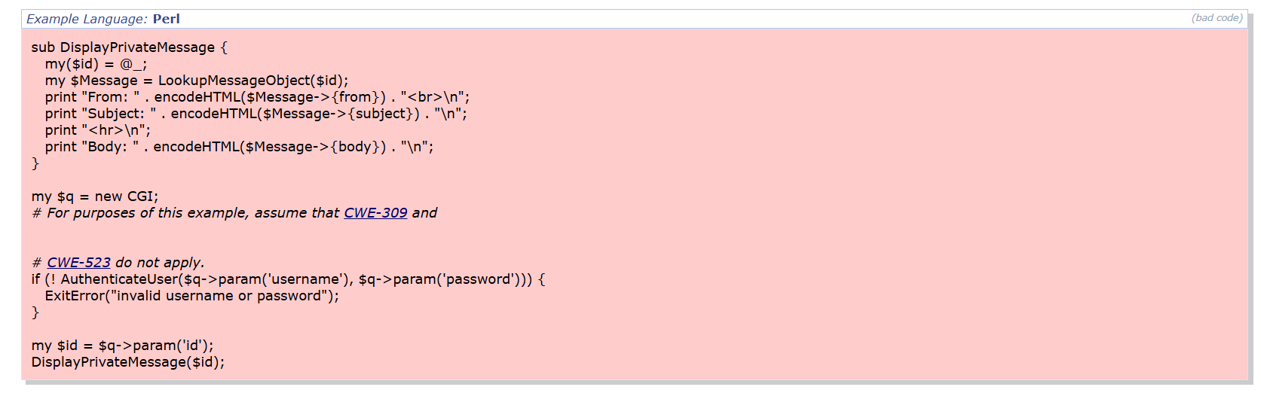
Recommendation:
- Implement Proper Authorization Checks: Ensure the application verifies whether the authenticated user has permission to access the requested resource before displaying sensitive information.
- Use Role-Based Access Control (RBAC): Assign roles and permissions to users so that only authorized users can access specific resources or functionalities.
- Validate Resource Ownership: Before retrieving data such as messages or files, confirm that the requested resource belongs to the currently logged-in user.
- Avoid Direct Object References: Do not allow users to directly access internal object identifiers like message IDs without proper validation.
- Perform Security Testing: Conduct regular vulnerability scans, code reviews, and penetration testing to identify and fix authorization flaws.

2.
Vulnerability Name: Sensitive Cookie Without 'Http Only' Flag
CWE: CWE - 1004
OWASP Category: A02:2025 Security Misconfiguration
Description: This vulnerability occurs when a web application sets sensitive cookies, such as session or authentication cookies, without enabling the Http Only attribute. The Http Only flag helps protect cookies by preventing them from being accessed through client-side scripts like JavaScript. If this flag is missing, attackers may exploit vulnerabilities such as CWE-79: Cross-Site Scripting (XSS) to steal the cookie from a user’s browser. Once the cookie is stolen, attackers can use it to hijack the user’s session and gain unauthorized access to the application. This can lead to account compromise , unauthorized actions, and exposure of sensitive user information.
Business Impact: This vulnerability can allow attackers to steal sensitive session cookies through client-side scripts, especially when combined with CWE-79: Cross-Site Scripting (XSS) attacks. If an attacker obtains a user’s session cookie, they can hijack the user’s active session and gain unauthorized access to the application. This may result in unauthorized account access, exposure of sensitive user information, and misuse of application features. For businesses, this can lead to data breaches, financial loss, damage to reputation, and loss of customer trust, especially if attacker-controlled sessions are used to perform malicious activities within the system.

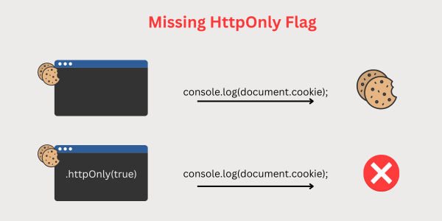
Recommendation:
- Enable the HttpOnly Attribute: Configure all sensitive cookies such as session cookies with the HttpOnly flag so they cannot be accessed through client-side scripts like JavaScript.
- Use Secure Cookies: Set the Secure attribute to ensure cookies are transmitted only over HTTPS connections.
- Implement Input Validation: Properly validate and sanitize user inputs to reduce the risk of CWE-79: Cross-Site Scripting (XSS) attacks that could exploit cookie vulnerabilities.
- Apply Strong Session Management: Use secure session identifiers and regularly regenerate session IDs after authentication.
- Regular Security Testing: Perform vulnerability scanning and security audits to detect and fix cookie security misconfigurations.

3.
Vulnerability Name: Use of Unmaintained Third-Party Components
CWE: CWE - 1104
OWASP Category: A03:2025 Software Supply Chain Failures
Description: This vulnerability occurs when an application uses third-party libraries, frameworks, or software components that are no longer maintained or supported by their developers. Because these components do not receive security updates or patches, any newly discovered vulnerabilities remain unfixed. Attackers can exploit these known weaknesses to compromise the application, gain unauthorized access, or execute malicious code. Using outdated or unmaintained components increases the risk of security breaches and can make the system vulnerable to multiple types of attacks. Proper dependency management and regular updates are necessary to ensure that all third-party components remain secure and supported.
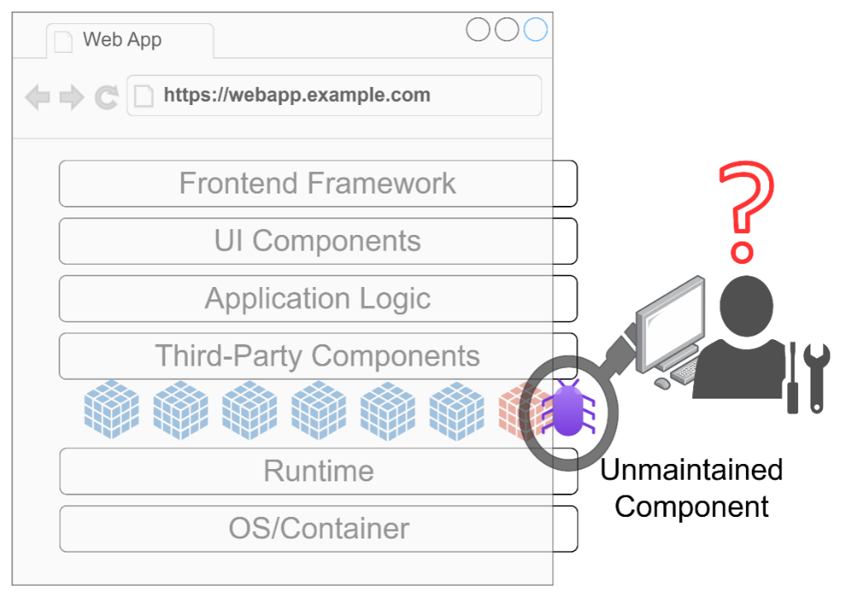
Business Impact: Using unmaintained third-party components can expose the application to known security vulnerabilities that are no longer patched by developers. Attackers can exploit these weaknesses to gain unauthorized access, execute malicious code, or compromise sensitive data. This can lead to data breaches, service disruptions, and system compromise. For organizations, such incidents may result in financial losses, legal and regulatory penalties, damage to business reputation, and loss of customer trust, especially if critical systems or user information are affected.

Recommendation:
- Replace Unmaintained Components: Identify third-party libraries or frameworks that are no longer supported and replace them with actively maintained and secure alternatives.
- Regularly Update Dependencies: Keep all third-party components updated to their latest stable versions to ensure known vulnerabilities are patched.
- Use Dependency Monitoring Tools: Implement tools that scan and monitor third-party libraries for known vulnerabilities and outdated versions.
- Maintain an Inventory of Components: Keep a record of all third-party components used in the application to easily track updates and security advisories.
- Perform Regular Security Audits: Conduct periodic security assessments and vulnerability scans to identify and address risks associated with external components.

4.
Vulnerability Name: Insufficient Entropy
CWE: CWE - 331
OWASP Category: A04:2025 Cryptographic Failures
Description: This vulnerability occurs when an application uses predictable or weak random values for security-sensitive operations such as generating session IDs, tokens, encryption keys, or passwords. Entropy refers to the level of randomness used in generating these values. If the randomness is insufficient, attackers may be able to predict or guess these values using brute force or pattern analysis. As a result, attackers could exploit the predictable values to hijack sessions, bypass authentication, or gain unauthorized access to the system.
Business Impact: Insufficient entropy can expose critical security mechanisms to attackers. If session identifiers, authentication tokens, or cryptographic keys are predictable, attackers may impersonate legitimate users, access sensitive data, or compromise secure communications. This can lead to account takeovers, data breaches, financial losses, and unauthorized system access. For organizations, such incidents may cause reputation damage, regulatory penalties, and loss of customer trust, especially if confidential information is compromised.

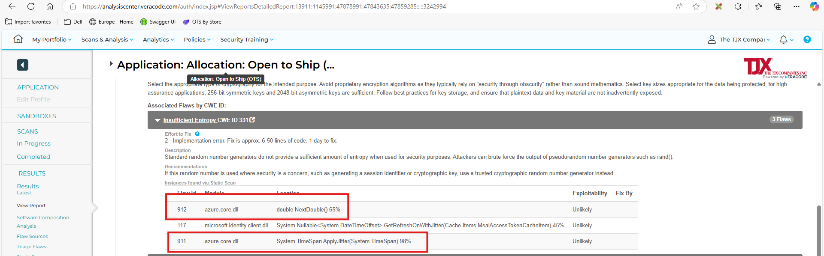

Recommendation:
- Use Cryptographically Secure Random Number Generators: Replace weak or predictable random number generators (such as rand() or similar functions) with secure cryptographic random generators designed for security-sensitive operations.
- Generate Strong Session Identifiers and Tokens: Ensure that session IDs, authentication tokens, and API keys are generated using high-entropy random values to prevent attackers from predicting them.
- Use Trusted Security Libraries: Implement well-established cryptographic libraries that provide secure random number generation instead of creating custom random functions.
- Follow Secure Coding Practices: Ensure that all security-related values such as passwords, encryption keys, and session tokens use sufficient randomness to prevent brute-force or prediction attacks.
- Perform Regular Security Testing: Conduct vulnerability scans and security reviews to detect weak random number generation and ensure strong entropy is used across the application.

5.
Vulnerability Name: Improper Control of Generation of Code ('Code Injection')
CWE: CWE – 94
OWASP Category: A05:2025 Injection
Description: This vulnerability occurs when an application allows untrusted user input to be included in dynamically generated code without proper validation or sanitization. As a result, attackers can inject malicious code into the application, which is then executed by the system. This can happen in situations where user input is directly used in scripts, commands, or interpreted code. If exploited, attackers may execute arbitrary commands, manipulate application logic, or gain unauthorized control over the system.
Business Impact: Code Injection vulnerabilities can have severe consequences for an organization. Attackers may gain the ability to execute malicious code on the server, leading to unauthorized access, data theft, system compromise, or service disruption. Sensitive information such as customer data, financial records, or internal system details may be exposed or modified. This can result in financial losses, operational downtime, regulatory penalties, and significant damage to the organization's reputation and customer trust.

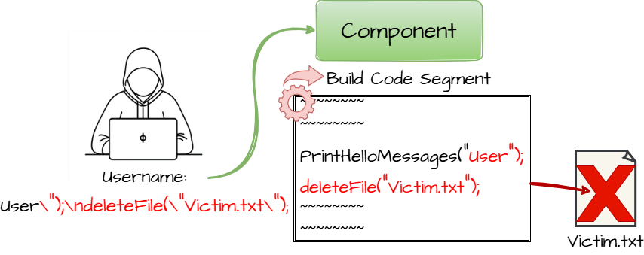

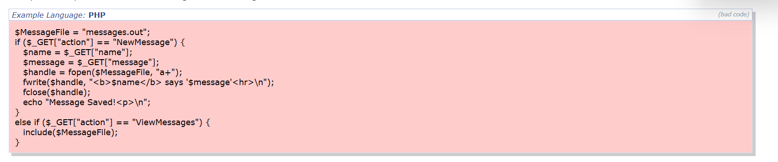

Recommendation:
- Validate and Sanitize User Input: Always validate and sanitize all user inputs before using them in application code to prevent malicious code injection.
- Avoid Dynamic Code Execution: Do not execute dynamically generated code using functions such as eval() or similar mechanisms unless absolutely necessary.
- Use Parameterized Functions: Implement secure coding practices such as parameterized queries or predefined commands instead of constructing code from user input.
- Apply Input Whitelisting: Allow only expected and safe input values rather than blocking known malicious patterns.
- Regular Security Testing: Perform regular code reviews, vulnerability scanning, and penetration testing to detect and fix code injection vulnerabilities early.

6
Vulnerability Name: Inconsistent Interpretation of HTTP Requests ('HTTP Request Smuggling')
CWE: CWE – 444
OWASP Category: A06:2025 Insecure Design
Description: This vulnerability occurs when different servers involved in processing an HTTP request (such as a front-end proxy and a back-end web server) interpret the request differently. This inconsistency usually happens due to improper handling of HTTP headers like Content-Length and Transfer-Encoding. Attackers can exploit this behavior to “smuggle” a hidden malicious request inside another request. As a result, the backend server may process unintended or malicious requests that bypass normal security controls.
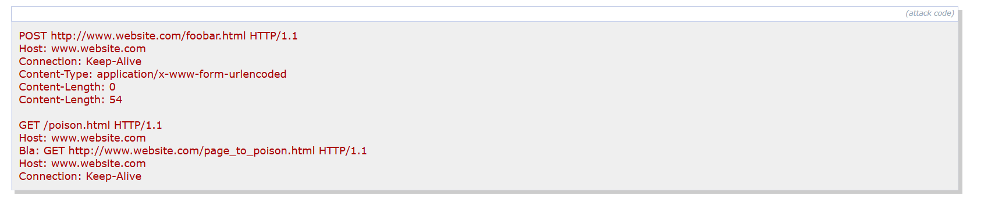
Business Impact: HTTP Request Smuggling can allow attackers to bypass security mechanisms such as authentication or web application firewalls. This may lead to unauthorized access to restricted pages, session hijacking, cache poisoning, or data leakage between users. In severe cases, attackers can manipulate requests to steal sensitive information or perform malicious actions on behalf of other users. For businesses, this can cause data breaches, service disruption, financial losses, and significant damage to the organization’s reputation and customer trust.
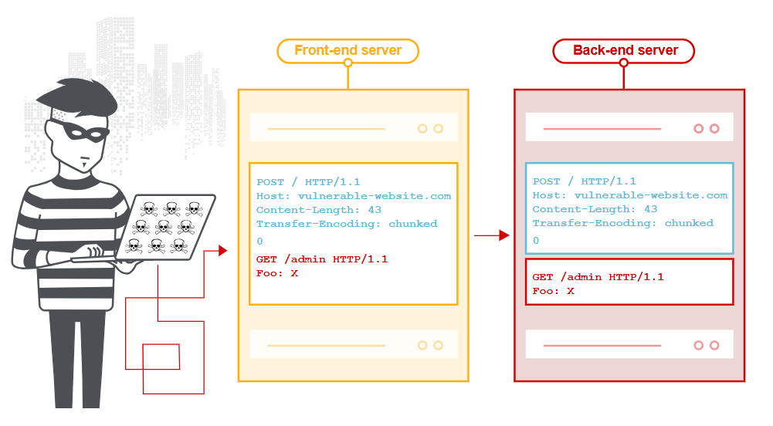

Recommendation:
- Use Consistent HTTP Protocols: Configure both front-end and back-end servers to use the same HTTP protocol (preferably HTTP/2) to avoid differences in request parsing.
- Validate and Normalize HTTP Requests: Ensure the front-end server validates and normalizes incoming HTTP requests before forwarding them to the back-end server to prevent ambiguous requests.
- Reject Ambiguous Headers: Configure servers to reject requests that contain conflicting headers such as Content-Length and Transfer-Encoding.
- Synchronize Server Configuration: Ensure that all servers, proxies, and load balancers in the request chain interpret HTTP requests in the same way and follow the same configuration standards.
- Perform Regular Security Testing: Conduct regular vulnerability scanning and penetration testing to detect HTTP request smuggling issues and fix them before deployment.

7.
Vulnerability Name: Authentication Bypass by Assumed-Immutable Data
CWE: CWE – 302
OWASP Category: A07:2025 Authentication Failures
Description: This vulnerability occurs when an application assumes that certain data cannot be modified by users and therefore trusts it during the authentication process. In some cases, applications rely on client-side data such as hidden form fields, cookies, URL parameters, or request headers to determine whether a user is authenticated. If attackers can modify this data, they may bypass authentication mechanisms and gain unauthorized access to restricted resources. Since the application incorrectly assumes that the data is immutable (unchangeable), attackers can manipulate it to impersonate legitimate users or access protected functions.
Business Impact: Authentication bypass vulnerabilities can have serious consequences for organizations. Attackers may gain unauthorized access to user accounts, administrative functions, or sensitive system resources. This can lead to data breaches, unauthorized transactions, and manipulation of sensitive information. For businesses, such attacks may result in financial losses, legal and regulatory penalties, service disruption, and significant damage to the organization's reputation and customer trust.

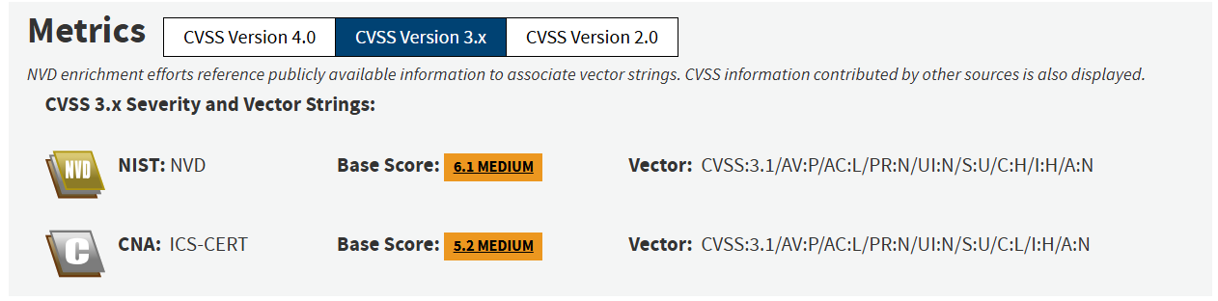

Recommendation:
- Do Not Trust Client-Side Data: Avoid relying on client-controlled data such as cookies, hidden fields, or URL parameters for authentication decisions.
- Perform Server-Side Validation: Always verify authentication and authorization on the server side to ensure that user identity and permissions are properly checked.
- Use Secure Session Management: Implement secure session tokens and validate them properly to ensure that only authenticated users can access protected resources.
- Protect Sensitive Data: Avoid storing authentication-related information in client-side data that can be easily modified by attackers.
- Conduct Regular Security Testing: Perform regular security assessments, code reviews, and vulnerability scans to identify and fix authentication bypass issues.

8.
Vulnerability Name: Improper Export of Android Application Components
CWE: CWE – 926
OWASP Category: A08:2025 Software or Data Integrity Failures
Description: This vulnerability occurs when Android application components such as Activities, Services, Broadcast Receivers, or Content Providers are unintentionally exported and made accessible to other applications. When components are exported without proper access restrictions or permissions, malicious applications installed on the same device can interact with them. Attackers may exploit this misconfiguration to access sensitive data, trigger unintended actions, or manipulate application behavior. This usually happens due to incorrect settings in the AndroidManifest.xml file where the android: exported attribute is set improperly or not defined securely.
Business Impact: Improperly exported components can allow malicious applications to access sensitive application functionality or data without proper authorization. This may lead to exposure of user data, unauthorized actions within the app, or privilege escalation. Attackers could misuse the exported components to manipulate app operations or access confidential information. For organizations, this can result in data breaches, loss of user privacy, reputational damage, and loss of customer trust, especially if the application handles sensitive personal or financial information.
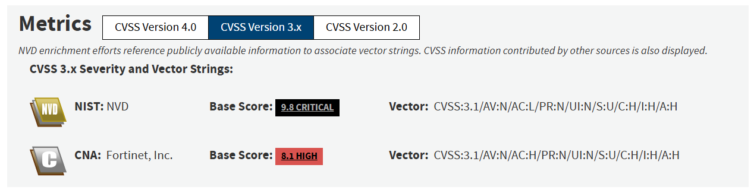

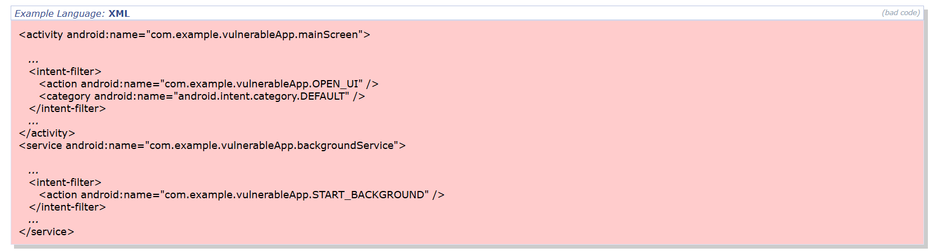

Recommendation:
- Restrict Exported Components: Explicitly define the android: exported attribute in the AndroidManifest.xml file and set it to "false" for components that should not be accessed by other applications. This prevents unauthorized apps from launching internal components.
- Use Permission Protection: Apply specific permissions to exported components so that only trusted applications can access them. Developers can use permission attributes or signature-level permissions to restrict access to apps signed with the same certificate.
- Limit Access to Content Providers: Configure proper read and write permissions for content providers and other shared components to ensure that only authorized applications can access sensitive data.
- Reduce the Attack Surface: Export only the components that are absolutely necessary for external interaction. Any component not required for communication with other apps should remain internal to the application.
- Perform Security Testing: Conduct regular mobile application security testing such as static code analysis, vulnerability scanning, and penetration testing to detect incorrectly exported components before deployment.

9.
Vulnerability Name: Insufficient Logging
CWE: CWE – 778
OWASP Category: A09:2025 Security Logging & Alerting Failures
Description: This vulnerability occurs when an application fails to properly log important security-related events such as login attempts, access to sensitive resources, system errors, or administrative actions. Without sufficient logging, suspicious activities and potential security incidents may go unnoticed. Attackers can exploit this weakness to perform malicious actions such as unauthorized access, privilege escalation, or data manipulation without being detected, because the system does not record enough information for monitoring or investigation.
Business Impact: Insufficient logging can significantly impact an organization’s ability to detect and respond to security incidents. If malicious activities are not recorded, organizations may be unable to identify the source or extent of an attack. This can lead to undetected data breaches, prolonged system compromise, and difficulty in forensic investigations. For businesses, this may result in financial losses, operational disruptions, regulatory compliance issues, and damage to the organization’s reputation and customer trust.
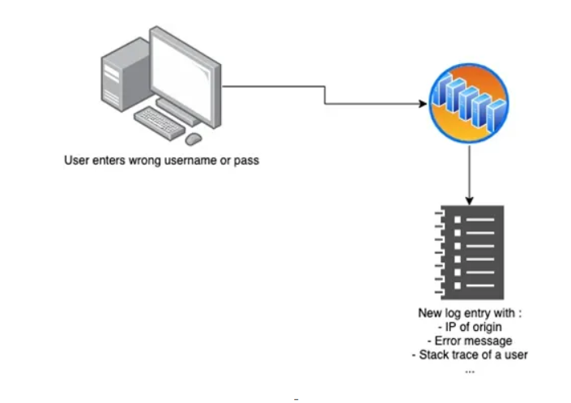

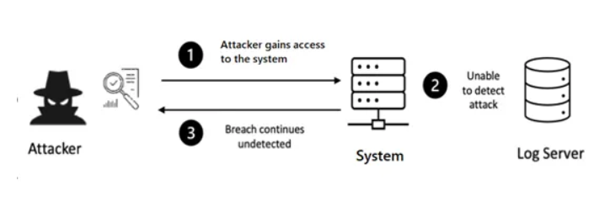Recommendation:
- Log Important Security Events: Ensure that critical events such as login attempts, failed logins, access control failures, administrative actions, and input validation errors are properly logged with sufficient details for investigation.
- Implement Centralized Logging: Store logs in a centralized logging system instead of keeping them only on local servers. Centralized logging helps security teams analyze events from multiple systems and detect suspicious activity more effectively.
- Enable Continuous Monitoring and Alerts: Use monitoring tools that analyze logs in real time and generate alerts for suspicious activities such as brute-force login attempts or unusual access patterns.
- Use Security Information and Event Management (SIEM) Tools: Implement SIEM systems to collect, correlate, and analyze logs from applications, servers, and network devices for better threat detection.
- Protect and Retain Logs Securely: Ensure logs are protected from tampering and retained for an appropriate period so they can be used for forensic investigations and compliance audits.
- Conduct Regular Security Reviews: Periodically review logs, perform security audits, and conduct vulnerability assessments to ensure logging and monitoring mechanisms are functioning effectively

10.
Vulnerability Name: Improper Cleanup on Thrown Exception
CWE: CWE – 460
OWASP Category: A10:2025 Mishandling of Exceptional Conditions
Description: This vulnerability occurs when a program fails to properly release or clean up resources after an exception is thrown during execution. Resources such as memory, file handles, database connections, or network sockets may remain open or partially initialized when the exception interrupts the normal flow of the program. If proper cleanup is not performed, attackers may exploit this weakness to cause resource exhaustion or inconsistent system states. This can lead to application instability or create opportunities for further exploitation.
Business Impact: Improper cleanup after exceptions can lead to system instability, application crashes, or denial-of-service (DoS) conditions due to unreleased resources. Over time, this can degrade system performance and disrupt normal operations. For organizations, such issues may cause service downtime, reduced application reliability, financial losses, and poor user experience. In critical systems, repeated failures may also impact business operations and damage the organization’s reputation.
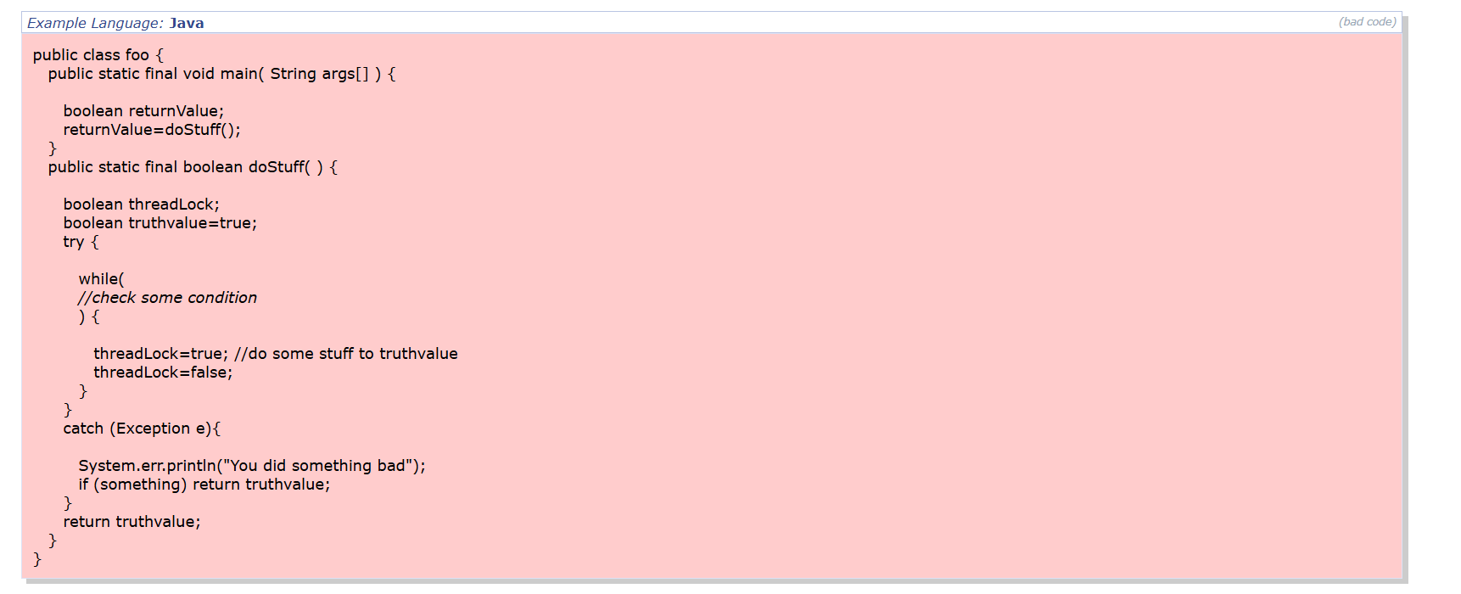

Recommendation:
- Ensure Proper Resource Cleanup: Always release resources such as memory, file handles, database connections, and locks when an exception occurs to prevent the application from remaining in an inconsistent state.
- Use Finally Blocks or Automatic Resource Management: Implement finally blocks or language features such as automatic resource management (e.g., try-with-resources or similar constructs) to guarantee that cleanup code is executed even when exceptions are thrown.
- Handle Exceptions Carefully: Design exception handling logic so that resources are properly released before exiting the function or terminating the process. Avoid leaving partially initialized objects or locked resources.
- Avoid Excessive Exception Throwing: Use exceptions only when necessary and ensure that the application properly handles them to prevent disruption in the normal execution flow.
- Perform Code Reviews and Security Testing: Conduct regular code reviews and use static analysis tools to detect improper exception handling and ensure proper cleanup mechanisms are implemented.

Stage – 2
Overview:
Nessus is a widely used vulnerability scanning tool developed by Tenable that helps organizations identify security weaknesses in computer systems, networks, and web applications. It is one of the most popular tools used by security professionals to detect vulnerabilities such as misconfigurations, missing security patches, open ports, weak passwords, and outdated software.
Nessus works by scanning target systems and comparing them with a large database of known vulnerabilities such as those listed in the Common Vulnerabilities and Exposures (CVE) database. After the scan is completed, the tool generates a detailed report showing detected vulnerabilities, their severity levels, possible impacts, and recommended solutions to fix them.
The tool supports different types of scans including network scanning, web application scanning, configuration auditing, and compliance checks. Security teams use Nessus to regularly monitor systems, improve security posture, and prevent cyber-attacks by identifying and fixing vulnerabilities before attackers can exploit them.
Because of its high accuracy, extensive vulnerability database, and easy-to-understand reports, Nessus is widely used in penetration testing, vulnerability management, and security auditing across many organizations.

Nessus also provides a user-friendly interface, making it easier for security teams to configure scans, monitor scan progress, and review results. Users can schedule automatic scans to regularly check systems for vulnerabilities and ensure that security issues are identified as early as possible.

Here are some of the benefits of using Nessus:
- Identifies Security Vulnerabilities: Nessus helps detect security weaknesses in systems, networks, and applications such as outdated software, missing patches, and configuration issues before attackers can exploit them.
- Large Vulnerability Database: The tool uses an extensive and regularly updated vulnerability database that includes known issues from sources like Common Vulnerabilities and Exposures (CVE), allowing it to detect thousands of vulnerabilities.
- Accurate and Detailed Reports: Nessus provides detailed scan reports with vulnerability descriptions, severity levels, affected systems, and recommended solutions, helping security teams quickly understand and fix problems.
- Supports Multiple Types of Scans: It can perform different types of scans such as network scanning, web application scanning, configuration auditing, and compliance checks, making it a versatile security tool.
- Regular Updates and Plugins: Developed by Tenable, Nessus receives regular plugin updates that help detect newly discovered vulnerabilities and security threats.
- User-Friendly Interface: Nessus has an easy-to-use interface that allows users to configure scans, schedule automated scanning tasks, and view reports without requiring advanced technical knowledge.
- Improves Overall Security: By identifying vulnerabilities early, organizations can fix security issues quickly and reduce the risk of cyber-attacks, data breaches, and system compromise.
- Supports Compliance Requirements: Nessus helps organizations meet security compliance standards and best practices by identifying configuration weaknesses and policy violations.

Step by step explanation of how Nessus works:
- Installation and Setup: First, the Nessus tool is installed on a system such as a Windows, Linux, or macOS machine. After installation, the user activates the scanner using a license key provided by Tenable and updates the vulnerability plugins so the scanner can detect the latest security issues.
- Create a New Scan: The user logs into the Nessus web interface and creates a new scan. During this step, the user selects the type of scan (for example: basic network scan or advanced scan) and provides the target details such as an IP address, domain name, or network range that needs to be scanned.
- Configure Scan Settings: The user configures scan settings such as scan policies, port scanning options, credentials for authenticated scans, and scheduling options. These settings help Nessus determine how deeply it should analyze the target system.
- Start the Vulnerability Scan: Once the scan configuration is complete, the user starts the scan. Nessus begins sending requests to the target system to discover open ports, running services, software versions, and system configurations.
- Analyze the Target System: Nessus compares the collected information with its vulnerability database, including publicly known vulnerabilities such as those listed in the Common Vulnerabilities and Exposures (CVE) database. It checks whether the target system contains known security flaws.
- Detect Vulnerabilities: During the scanning process, Nessus identifies vulnerabilities such as missing security patches, outdated software, weak encryption protocols, open ports, and misconfigured services.
- Classify Vulnerabilities by Severity: After detecting vulnerabilities, Nessus classifies them based on their severity levels such as Critical, High, Medium, Low, and Informational. This helps security teams prioritize which issues should be fixed first.
- Generate the Scan Report: When the scan is completed, Nessus generates a detailed report. The report includes vulnerability descriptions, affected systems, severity levels, risk information, and recommended solutions to fix each vulnerability.
- Review and Remediation: Security teams review the report and apply necessary fixes such as installing security patches, updating software, closing unnecessary ports, or correcting configuration errors.
- Continuous Monitoring: Organizations usually perform regular scans using Nessus to continuously monitor their systems and ensure that new vulnerabilities are detected and fixed quickly.

What are the features seen in the Nessus:
- Comprehensive Vulnerability Scanning: Nessus can scan networks, systems, and applications to identify security vulnerabilities such as missing patches, outdated software, weak configurations, and open ports.
- Large Plugin Database: Nessus uses thousands of regularly updated plugins provided by Tenable to detect known vulnerabilities and security weaknesses in different operating systems and applications.
- CVE Detection: The scanner detects vulnerabilities listed in the Common Vulnerabilities and Exposures (CVE) database, helping organizations identify publicly known security issues affecting their systems.
- Authenticated and Unauthenticated Scanning: Nessus supports both authenticated scans (using login credentials for deeper analysis) and unauthenticated scans (external scanning without login access).
- Detailed Vulnerability Reports: After completing a scan, Nessus generates detailed reports that include vulnerability descriptions, severity levels, affected systems, and recommended solutions.
- Severity Classification: Detected vulnerabilities are categorized into Critical, High, Medium, Low, and Informational levels, helping security teams prioritize the most serious risks.
- Configuration and Compliance Auditing: Nessus can check system configurations against security policies and compliance standards to identify misconfigurations.
- Automatic Updates: The tool regularly updates its vulnerability database and plugins to detect newly discovered security threats.
- User-Friendly Web Interface: Nessus provides an easy-to-use web-based interface that allows users to configure scans, monitor scan progress, and review results efficiently.
- Scan Scheduling: Users can schedule automatic scans to regularly check systems for vulnerabilities and maintain continuous security monitoring.

What are the Use Cases of Nessus:
- Network Vulnerability Assessment: Nessus is used to scan networks and identify security weaknesses such as open ports, vulnerable services, and misconfigured network devices that could be exploited by attackers.
- Patch Management Verification: Organizations use Nessus to detect systems with missing security patches or outdated software versions by comparing them with known vulnerabilities listed in the Common Vulnerabilities and Exposures (CVE) database.
- Web Application Security Testing: Nessus can identify common web vulnerabilities such as misconfigurations, outdated web servers, and insecure protocols that may expose web applications to attacks.
- Compliance and Security Auditing: Nessus helps organizations check whether their systems comply with security standards and policies by auditing system configurations and identifying policy violations.
- Penetration Testing Support: Security professionals use Nessus during penetration testing to quickly identify vulnerabilities that attackers might exploit in a system or network.
- Malware Detection: Nessus can detect systems that may be infected with malware or communicating with known malicious hosts.
- Configuration Assessment: The tool helps detect insecure system configurations such as weak encryption settings, default credentials, and improperly configured services.
- Continuous Security Monitoring: Organizations schedule regular scans with Nessus to continuously monitor their systems for new vulnerabilities and maintain strong cybersecurity protection.

Target website :- http://testfire.net/
Target ip address:- 65.61.137.117

List of Vulnerabilities:

S.No. | Vulnerability Name | Severity | Plugins
1 | Service Detection | INFO | 22964
2 | Apache Tomcat Detection | INFO | 39446
3 | HTTP Server Type and Version | INFO | 10107
4 | Nessus SYN scanner | INFO | 11219
5 | Common Platform Enumeration (CPE) | INFO | 45590
6 | Device Type | INFO | 54615
7 | Nessus Scan Information | INFO | 19506
8 | OS Fingerprints Detected | INFO | 209654
9 | OS Identification | INFO | 11936
10 | Traceroute Information | INFO | 10287

Report
1.
Vulnerability Name:- 22964 - Service Detection
severity : - INFO
Plugin:- 22964
Port :- 443
Description:- The remote host is running one or more services that were detected by the scanner during the network scan. The Nessus vulnerability scanner identified open ports and attempted to determine which services or applications are listening on those ports. This information helps security analysts understand the services exposed by the target system.
This finding is informational and does not necessarily indicate a vulnerability. However, the detection of active services may reveal potential entry points for attackers if the services are outdated, misconfigured, or unnecessary. Attackers often perform service detection during reconnaissance to identify possible targets for exploitation.
Solution: - Review the detected services and verify that they are required for normal system operations. Disable or remove any unnecessary services to reduce the attack surface. Ensure that all running services are properly configured, restricted by firewall rules, and updated with the latest security patches. Regularly monitor and audit open ports and services to maintain system security.
Business Impact: - Although this finding is informational, exposed services may provide attackers with valuable information about the system’s environment. If unnecessary or vulnerable services are running, attackers may attempt to exploit them to gain unauthorized access, disrupt services, or compromise sensitive data. Maintaining unnecessary services can increase the organization’s attack surface, potentially leading to security incidents, service disruptions, and reputational damage if exploited.
2.
Vulnerability Name:- 39946 - Apache Tomcat Detection
severity : - INFO
Plugin:- 39946
Port :- 443
Description:- The remote web server is running Apache Tomcat, which is an open-source Java servlet container used to host web applications. The Nessus vulnerability scanner detected the presence of Apache Tomcat on the target system during the scan. This detection is informational and indicates that the server software is identifiable through service responses, banners, or configuration details.
Although this is not a vulnerability by itself, revealing the presence and version of Apache Tomcat may provide useful information to attackers during the reconnaissance phase. Attackers may use this information to search for known vulnerabilities related to that specific version and attempt to exploit them if the software is outdated or misconfigured.
Solution: - Verify that the installed version of Apache Tomcat is up to date and patched with the latest security updates. Disable unnecessary services and restrict access to the Tomcat management interfaces if they are not required. Configure the server to hide or limit service banners that reveal software version information. Implement proper firewall rules and security configurations to restrict unauthorized access to the web server.
Business Impact: - Although this finding is informational, publicly exposing the presence of Apache Tomcat can help attackers identify the technologies used by the organization. If the Tomcat server is outdated or improperly configured, attackers may exploit known vulnerabilities to gain unauthorized access, execute malicious code, or compromise hosted web applications. This could lead to data breaches, service disruptions, and potential damage to the organization’s reputation and customer trust.

3.
Vulnerability Name:- 10107 - HTTP Server Type and Version
severity : - INFO
Plugin:- 10107
Port :- 8080
Description:- The scan detected the type and version of the HTTP server running on the target system. The Nessus vulnerability scanner identified the web server software by analyzing the HTTP response headers returned by the server. These headers often reveal information about the server type and version, such as the web server software being used and its release number.
Although this finding is informational and does not directly represent a vulnerability, exposing server type and version information may assist attackers during the reconnaissance phase. Attackers can use this information to search for publicly known vulnerabilities associated with the identified web server version and attempt targeted attacks.
Solution: - Configure the web server to hide or minimize the server banner information that reveals the server type and version. This can be done by modifying server configuration settings to disable version disclosure in HTTP response headers. Additionally, ensure that the web server software is regularly updated with the latest security patches and follow secure configuration practices to reduce potential risks.
Business Impact: - Public disclosure of HTTP server type and version information can provide attackers with valuable insight into the technologies used by an organization. This information can help them identify potential vulnerabilities related to the detected server version and launch targeted attacks. If exploited, such vulnerabilities could lead to unauthorized access, service disruption, or compromise of web applications, potentially resulting in financial losses and damage to the organization’s reputation.

4.
Vulnerability Name:- 11219 - Nessus SYN scanner
severity : - INFO
Plugin:- 11219
Port :- 443
Description:- The scan identified that the port is open using the SYN scanning technique performed by the Nessus vulnerability scanner. SYN scanning is a method used to determine whether a port on a target system is open, closed, or filtered. During this process, the scanner sends a SYN packet to the target port and analyzes the response to identify the port status.
This finding indicates that the port is accessible and responding to connection requests. It does not represent a direct vulnerability but provides information about the network services that are exposed. Open ports may allow access to services running on the system, which could potentially be targeted by attackers if they contain vulnerabilities or are improperly configured.
Solution: - Review the open ports on the system and verify that they are required for normal operations. Close or disable any unnecessary ports to reduce the attack surface. Implement firewall rules or access control mechanisms to restrict access to critical services only from trusted networks or users. Additionally, ensure that services running on open ports are properly secured and updated with the latest security patches.
Business Impact: - Although this finding is informational, open and accessible ports can provide attackers with useful information about available services on the system. If unnecessary ports are exposed or services running on those ports contain vulnerabilities, attackers may attempt to exploit them to gain unauthorized access or disrupt services. Managing open ports properly helps reduce the organization's attack surface and improves overall network security.

5.
Vulnerability Name:- 45590 - Common Platform Enumeration
severity : - INFO
Plugin:- 45590
Port :- N/A
Description:- The scan detected information related to the system’s platform using Common Platform Enumeration (CPE). CPE is a standardized naming scheme used to identify and classify software, operating systems, and hardware platforms. The Nessus vulnerability scanner uses this information to map detected technologies on the target system with known vulnerabilities available in public databases.
This finding is informational and indicates that the scanner has successfully identified the platform or software components running on the target system. By determining the CPE identifiers, Nessus can more accurately match the system against known vulnerabilities and security advisories.
Solution:- Ensure that all detected software, operating systems, and applications are updated with the latest security patches. Regularly review system configurations and maintain proper patch management to address any vulnerabilities associated with the identified platforms. Limiting unnecessary exposure of system information and maintaining updated systems can help reduce potential security risks.
Business Impact: - Although this finding is informational, identifying the platform and software components used by an organization may provide attackers with useful reconnaissance information. Attackers could use this information to search for known vulnerabilities related to the identified platforms and attempt targeted attacks. Proper system maintenance, updates, and security monitoring are necessary to minimize potential risks associated with exposed platform information.

6.
Vulnerability Name:- 54165 - Device Type
severity : - INFO
Plugin:- 54165
Port :- N/A
Description:- The Device Type plugin identifies the type of device detected during the scan, such as a router, firewall, server, workstation, printer, or network appliance. This information is gathered through network fingerprinting and service detection techniques.
The plugin does not indicate a vulnerability but provides informational details about the scanned asset. Security teams can use this information to better understand the network environment, classify assets, and manage devices appropriately during vulnerability assessments and security audits.
This plugin helps in asset identification and inventory management, which is important for maintaining visibility of devices connected to the network.
Solution:- This plugin is informational and does not represent a direct security vulnerability. However, organizations should maintain a proper asset management and device classification process. All detected devices should be reviewed and documented in the organization’s asset inventory. Administrators should ensure that each device type is properly configured, patched, and monitored according to the organization’s security policies. Regular network scans and asset audits should also be performed to identify new or unauthorized devices connected to the network.
Business Impact:- Although this issue does not pose a direct security risk, identifying device types helps organizations maintain better visibility and control over their network infrastructure. If device information is not properly managed, unauthorized or unmanaged devices could remain on the network, potentially leading to security gaps, misconfigurations, or increased risk of cyber-attacks. Proper device identification supports effective vulnerability management, compliance requirements, and overall network security governance.

7.
Vulnerability Name:- 19506 - Nessus Scan Information
severity : - INFO
Plugin:- 19506
Port :- N/A
Description:- The Nessus Scan Information finding provides details on how a target system responds to a Nessus vulnerability scan, including open ports, running services, operating system fingerprints, and network behavior. This plugin is informational and does not indicate an actual security vulnerability, but it helps organizations understand their network environment and asset configurations.
Solution: No direct remediation is required, as this is not a vulnerability. Organizations should ensure that scans are authorized, maintain an up-to-date asset inventory, and monitor any unusual responses revealed by the scan. Additionally, exposed services should be reviewed and hardened according to security policies to minimize unnecessary network exposure.
Business Impact: Although informational, this data is valuable for maintaining network visibility and security awareness. If exposed externally, it could potentially be used by attackers for reconnaissance. Properly leveraging scan information supports effective asset management, compliance with security standards, and risk management, helping organizations identify misconfigurations and strengthen overall network security.

8.
Vulnerability Name:- 209654 - OS Fingerprints Detected
severity : - INFO
Plugin:- 209654
Port :- N/A
Description:- The OS Fingerprints Detected plugin identifies the operating system of a device based on network responses, such as TCP/IP stack behavior or service banners. This finding is informational and does not indicate a direct vulnerability, but it helps security teams understand the types of operating systems running on the network. This information can be useful for asset management, patch planning, and network monitoring.
Solution: No immediate remediation is required since this is informational. Organizations should ensure that all systems are properly documented in the asset inventory and kept up to date with security patches. Additionally, unnecessary services or banners that reveal OS information can be minimized or hidden to reduce the potential for external reconnaissance.
Business Impact: While not directly harmful, OS fingerprinting information could potentially be exploited by attackers to plan targeted attacks. Maintaining awareness of the operating systems in use helps with risk management, patch management, and compliance. Properly managing this information strengthens overall network security and reduces exposure to threats that target specific OS vulnerabilities.

9.
Vulnerability Name:- 11936 - OS Identification
severity : - INFO
Plugin:- 11936
Port :- N/A
Description:- The OS Identification plugin detects and reports the operating system of a scanned host by analyzing network responses, open ports, and service characteristics. This finding is informational and does not represent an actual vulnerability. It provides insight into the types of operating systems running in the network environment, which is useful for asset management, planning updates, and vulnerability assessment.
Solution: No direct remediation is needed as this is informational. Organizations should ensure that all systems are accurately documented in the asset inventory and maintained with up-to-date patches. Additionally, reducing unnecessary OS information disclosure—such as hiding banners or service details—can help limit the exposure of OS details to potential attackers.
Business Impact: Although this information does not pose an immediate risk, knowledge of operating systems could assist attackers in planning targeted attacks. Proper OS identification supports effective asset management, compliance, and patch management, helping organizations maintain a secure and well-monitored network environment while minimizing exposure to potential threats.

10.
Vulnerability Name:- 10287 - Traceroute Information
severity : - INFO
Plugin:- 10287
Port :- 0
Description:- The Traceroute Information plugin provides details about the network path between the scanning system and the target host. It identifies intermediate routers, gateways, and network segments along the path. This finding is informational and does not represent a security vulnerability. It helps organizations understand network topology and connectivity, which is useful for network management, troubleshooting, and planning security measures.
Solution: No direct remediation is required since this is informational. Organizations should ensure that network devices are properly configured, secured, and monitored. Limiting unnecessary exposure of routing information, such as filtering ICMP responses from public-facing devices, can reduce the potential for attackers to map the network.
Business Impact: While this information does not pose a direct threat, it could be leveraged by attackers to understand the network layout for reconnaissance purposes. Maintaining awareness of network paths and properly securing routing devices enhances network security, supports compliance, and reduces the risk of targeted attacks based on network mapping.

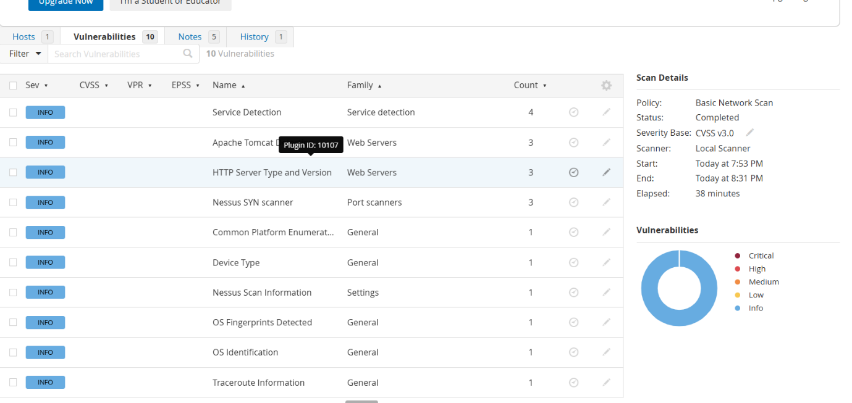
Stage – 3

Title:
Integrate Zscaler with Identity Providers (IdPs) such as Azure AD, Okta, and Active Directory for seamless authentication and authorization.
Introduction to Zscaler
Zscaler is a cloud-native security platform designed to secure internet access and private applications without the need for traditional on-premises security appliances. Unlike legacy security models, Zscaler routes traffic through its global cloud network, enabling organizations to enforce security policies at scale while providing users with fast and reliable access. By moving security to the cloud, Zscaler eliminates the need for hardware VPNs, reduces latency, and simplifies network management. It offers solutions like ZIA (Zscaler Internet Access) for secure web traffic and ZPA (Zscaler Private Access) for secure access to internal applications, providing a modern foundation for identity-centric security.
Understanding Identity Providers (IdPs)
Identity Providers (IdPs) such as Azure Active Directory, Okta, and traditional Active Directory serve as the backbone of modern authentication and authorization frameworks. IdPs verify user identities and provide authentication tokens that applications and services can trust. They also maintain information about user roles, group memberships, and access rights. When integrated with Zscaler, IdPs enable Single Sign-On (SSO) capabilities and enforce consistent identity-based policies across cloud and on-premises applications, reducing administrative overhead and improving security.
Authentication vs. Authorization in Network Security
Authentication and authorization, though closely related, serve distinct roles in security. Authentication is the process of verifying that a user is who they claim to be, typically through passwords, certificates, or multi-factor authentication. Authorization determines what the authenticated user is allowed to do, such as accessing specific applications or resources. Integrating Zscaler with IdPs ensures that both authentication and authorization are centralized and dynamic, enabling policies that grant access based on identity, role, device posture, and real-time risk signals rather than static network location.
Benefits of Integrating Zscaler with IdPs
Integrating Zscaler with enterprise IdPs provides multiple benefits, including seamless user experience, enhanced security, and simplified administration. Users gain Single Sign-On access across cloud and on-premises applications, eliminating the need for multiple passwords. IT teams can centrally manage user roles and permissions, enforce least-privilege access, and dynamically adapt policies as users change roles or devices. From a security perspective, the integration reduces attack surfaces by ensuring that access is identity-driven and contextual, limiting exposure to lateral movement or compromised credentials.
Single Sign-On (SSO) Overview
Single Sign-On (SSO) allows users to authenticate once through their IdP and gain access to multiple applications without repeated logins. Zscaler leverages SSO using standard protocols such as SAML, OAuth, and OpenID Connect. By integrating SSO with Zscaler, organizations provide employees and contractors with frictionless access while maintaining strong identity verification and session monitoring. SSO reduces password fatigue, minimizes credential reuse risks, and ensures consistent policy enforcement across both internal and cloud applications.
Zscaler and Azure Active Directory Integration
Integrating Zscaler with Azure Active Directory (Azure AD) enables seamless authentication for enterprise users accessing both internet and internal applications. Before integration, administrators must ensure that users and groups in Azure AD are accurately maintained and that multi-factor authentication is enabled where required. The integration process involves registering Zscaler as an enterprise application in Azure AD, configuring SAML-based Single Sign-On (SSO), and mapping user attributes such as email and group membership to Zscaler policies. Once configured, users can authenticate through Azure AD, and Zscaler enforces access policies dynamically based on roles, device posture, and location. This approach eliminates the need for VPN credentials and ensures that only authorized users can access sensitive resources.
Zscaler and Okta Integration
Okta serves as a cloud-first identity provider, offering robust SSO and identity management capabilities. To integrate Zscaler with Okta, administrators must first create a Zscaler application in the Okta admin console, configure SAML settings, and define attribute mappings for user email, roles, and group membership. Once configured, Okta handles authentication and passes identity information to Zscaler, which enforces policy-based access control. This integration provides a unified login experience, reduces password fatigue, and allows administrators to centrally manage user access while maintaining compliance with security policies.
Zscaler and Active Directory (AD) Integration
Traditional Active Directory can also serve as an IdP for Zscaler, enabling on-premises user authentication. This requires deploying a Zscaler Authentication Connector (ZAC) or Zscaler App Connector within the network. The connector communicates with the AD domain controllers to authenticate users and fetch group memberships. Access policies in Zscaler can then be applied based on AD groups, departments, or roles. This integration allows enterprises to leverage existing AD infrastructure while moving toward identity-centric security models without disrupting existing workflows.
User Provisioning and Group Mapping
Automating the synchronization of users and groups from IdPs to Zscaler is crucial for effective policy enforcement. By mapping IdP groups to Zscaler policies, administrators can dynamically assign access rights as users change roles, join departments, or leave the organization. This eliminates manual provisioning, reduces human error, and ensures that policies remain up-to-date. Integration with SCIM-enabled IdPs or built-in provisioning connectors allows automatic user lifecycle management, improving operational efficiency and reducing security risks associated with stale accounts.
Configuring Authentication Policies in Zscaler
Zscaler allows administrators to define granular authentication policies that enforce access based on user identity, role, device type, and location. Policies can be configured to restrict access to sensitive applications for certain groups, require multi-factor authentication for high-risk sessions, or deny connections from unmanaged devices. This identity-based approach ensures that the principle of least privilege is applied consistently across the network, and access decisions are made dynamically in real-time rather than relying on static network controls.
Security Considerations for IdP Integration
Integrating Zscaler with IdPs introduces a critical dependency on identity security. Multi-factor authentication (MFA) should be enforced for all sensitive users, and conditional access policies can restrict logins based on location, device posture, or risk signals. Additionally, administrators must monitor user activity, manage privileged accounts carefully, and implement identity governance to ensure compliance. Properly securing the IdP and integration endpoints prevents attackers from bypassing Zscaler policies or exploiting misconfigurations.
Troubleshooting Authentication Issues
Authentication integration can encounter common issues, such as failed SSO logins, misconfigured SAML assertions, or incorrect attribute mappings. Troubleshooting involves checking IdP logs, verifying certificates, ensuring correct group mappings, and validating Zscaler connector configurations. Implementing test users and monitoring login attempts helps isolate the root cause of failures quickly. Documentation of error codes and resolutions improves operational efficiency and ensures minimal disruption to end-users.
Monitoring and Logging
Monitoring user authentication events in Zscaler is essential for security and compliance. Zscaler logs include details of user logins, access attempts, session durations, and any policy violations. These logs can be exported to SIEM systems for advanced analysis, alerting, and reporting. Effective logging provides visibility into potential security incidents, allows audits for regulatory compliance, and helps administrators refine policies based on user behavior and risk patterns.
Use Cases for Zscaler and IdP Integration
Zscaler-IdP integration supports multiple real-world use cases, such as providing secure remote access without VPNs, enforcing access controls for cloud applications, and enabling segmented access to internal resources. Employees can securely connect from home, contractors can access only authorized applications, and security teams can isolate high-risk users or devices. This model aligns with Zero Trust principles by ensuring identity-based access and reducing the attack surface across hybrid environments.
Best Practices and Recommendations
To maximize the benefits of Zscaler-IdP integration, organizations should follow best practices such as enforcing MFA, regularly auditing IdP and Zscaler policies, and automating user provisioning. Group-based access control should be applied consistently, and idle or inactive accounts should be deactivated promptly. Continuous monitoring, logging, and regular security reviews ensure that access remains secure, scalable, and compliant with regulatory requirements. Adopting these practices strengthens the overall security posture while providing seamless and efficient user experiences.

Conclusion:-
In conclusion, exploring the integration of Zscaler with Identity Providers (IdPs) such as Azure AD, Okta, and Active Directory has provided a comprehensive understanding of modern identity-centric security frameworks.
Stage – 1
The first stage of the project focused on integrating Zscaler with Identity Providers (IdPs) such as Azure Active Directory, Okta, and Active Directory to enable secure authentication and authorization. This integration supports modern identity-based security by implementing technologies such as Single Sign-On (SSO) and centralized access control. Through this approach, users are authenticated through a trusted identity provider before gaining access to applications or internet resources.
During this stage, multiple security vulnerabilities related to access control, authentication failures, cryptographic weaknesses, insecure design, and logging issues were identified and analyzed. Each vulnerability was studied with its description, business impact, and recommended mitigation strategies. Addressing these vulnerabilities helps organizations strengthen their security posture, protect sensitive data, and prevent unauthorized access.
Overall, this stage highlights the importance of secure identity management, proper authorization mechanisms, and secure application design in building a reliable Zero Trust security architecture. Implementing the recommended security controls significantly reduces the risk of cyber-attacks and ensures that only authenticated and authorized users can access critical resources.
Stage – 2
The second stage of the project focused on performing a vulnerability assessment using the Nessus vulnerability scanning tool. Nessus was used to scan the target system to identify potential security weaknesses, misconfigurations, and exposed services. The scanning process demonstrated how security professionals can detect vulnerabilities early by analyzing network services, operating system information, open ports, and server configurations.
The scan results identified several informational findings, including service detection, server identification, open ports, operating system fingerprinting, and network path information. Although these findings were not critical vulnerabilities, they provide valuable insight into the target system’s infrastructure. Such information can potentially be used by attackers during the reconnaissance phase to identify possible attack vectors.
This stage emphasizes the importance of regular vulnerability scanning, system monitoring, and proper configuration management. By continuously assessing systems using tools like Nessus, organizations can detect potential security risks early, reduce the attack surface, and maintain a strong security posture.
Stage – 3
The third stage of the project explored the integration of Zscaler with Identity Providers such as Azure AD, Okta, and Active Directory to implement secure and seamless authentication across enterprise environments. This integration enables identity-based access control, allowing organizations to enforce security policies based on user identity, role, device status, and location rather than relying solely on traditional network boundaries.
By implementing Single Sign-On (SSO) and centralized identity management, organizations can improve both security and user experience. Users can access multiple applications through a single authentication process, while administrators maintain full control over access policies, user provisioning, and security monitoring. The integration also supports advanced security features such as multi-factor authentication, conditional access policies, and role-based access control, which further strengthen protection against unauthorized access.
Overall, this stage demonstrates how combining cloud security platforms with modern identity management systems supports the implementation of a Zero Trust security model. This approach enhances security, simplifies administration, and ensures that only verified and authorized users can access critical applications and resources.
Considering the future scope, Stage 1 highlights the growing importance of integrating cloud security platforms with modern Identity Providers to strengthen authentication and authorization mechanisms. As organizations continue to adopt cloud-based infrastructures, identity-centric security models such as Zero Trust will become increasingly critical. Future advancements may include the integration of AI-driven identity analytics, adaptive authentication, and advanced behavioural monitoring to detect suspicious activities in real time. These developments will further enhance the effectiveness of identity-based access control, ensuring stronger protection against unauthorized access and cyber threats.
Stage 2 demonstrates the future potential of vulnerability assessment tools like Nessus in improving cybersecurity practices. As cyber threats continue to evolve, vulnerability scanning tools are expected to become more intelligent through automation, machine learning, and real-time threat intelligence integration. Future systems may automatically prioritize vulnerabilities, recommend remediation strategies, and integrate directly with patch management systems for faster response. This evolution will enable organizations to conduct continuous security monitoring, reduce human effort, and strengthen their overall security posture by identifying and mitigating vulnerabilities more efficiently.
Stage 3 focuses on the integration of Zscaler with enterprise Identity Providers such as Azure Active Directory, Okta, and Active Directory to establish a unified and secure identity management framework. This integration supports the transition from traditional network-based security models to a modern Zero Trust architecture where access decisions are based on user identity, device posture, and contextual information. The implementation of Single Sign-On enables seamless access to applications while reducing password management issues for users. Centralized policy management allows administrators to enforce consistent security controls such as multi-factor authentication and role-based access control. Automated user provisioning and group synchronization improve operational efficiency and reduce the risk of unauthorized access caused by outdated accounts. Additionally, real-time monitoring and logging capabilities provide visibility into user activities and help detect potential security incidents. Overall, this integration creates a scalable and secure foundation for organizations adopting cloud technologies while ensuring strong access control, improved user experience, and enhanced protection against evolving cyber threats.

Future Scope
Future of Cloud Security and Identity-Based Access Control
The future of cloud security and identity-based access control is highly promising as organizations increasingly adopt cloud platforms and remote working environments. Modern enterprises depend on secure access to cloud applications and internal systems, making strong identity management and security monitoring essential. Integrating cloud security platforms with Identity Providers ensures that organizations can maintain secure authentication and authorization while supporting scalable and flexible infrastructure.
Here are some of the key trends expected to shape the future of cloud security and identity management:
● Increased focus on Zero Trust security: Organizations are moving away from traditional perimeter-based security models toward Zero Trust architectures. In the future, identity verification, device validation, and contextual access policies will play a major role in protecting enterprise resources.
● Integration of Artificial Intelligence (AI) and Machine Learning (ML): AI and ML technologies will be increasingly used in cybersecurity platforms to detect unusual user behavior, identify threats, and automate security responses. These technologies will help security systems detect attacks faster and reduce manual analysis.
● Growth of cloud-native security platforms: As more organizations migrate to cloud environments, security solutions like Zscaler will continue to evolve to provide scalable, cloud-delivered protection without relying on traditional hardware security appliances.
● Improved identity management and authentication methods: Future systems will rely more on advanced authentication techniques such as biometric authentication, adaptive authentication, and password less login mechanisms to enhance both security and user experience.
Future Scope of Vulnerability Assessment and Security Testing
The future scope of vulnerability assessment and security testing is expanding as digital infrastructures grow more complex. Organizations rely heavily on applications, networks, and cloud platforms to conduct daily operations, and therefore they must ensure that these systems remain secure against emerging cyber threats.
Here are some key trends that will influence the future of vulnerability assessment and security testing:
● Continuous vulnerability scanning: Instead of periodic security checks, organizations will increasingly adopt continuous vulnerability monitoring to identify threats in real time throughout the system lifecycle.
● Automation in security testing: Security testing tools such as Nessus, OWASP ZAP, and Burp Suite will become more automated, enabling faster vulnerability detection and reducing manual effort in security assessments.
● Integration with DevSecOps pipelines: Security testing will be integrated directly into software development pipelines so that vulnerabilities can be detected during development stages rather than after deployment.
● Advanced threat intelligence integration: Security tools will incorporate real-time threat intelligence feeds to identify newly discovered vulnerabilities and provide faster remediation guidance.
● Cloud-based testing environments: As applications move to cloud environments, security testing tools will increasingly support cloud-native infrastructures, enabling scalable and flexible vulnerability assessments.
Future Scope of SOC / SIEM and Security Monitoring
The integration of Zscaler with enterprise Identity Providers provides a strong foundation for future enhancements in Security Operations Center (SOC) and Security Information and Event Management (SIEM) systems. This integration enables centralized authentication monitoring, advanced access control, and improved visibility into security events across the network.
Future improvements may include deeper integration with additional identity providers such as Google Workspace, Ping Identity, and OneLogin to support diverse user environments including employees, partners, and external collaborators. Advanced conditional access policies combined with threat intelligence platforms can enable dynamic authentication decisions based on user behavior and risk levels.
Further integration with Endpoint Detection and Response (EDR) tools such as Microsoft Defender, CrowdStrike, and Sentinel One will allow security teams to evaluate device health before granting access to critical resources. Implementing Privileged Access Management (PAM) solutions will also help organizations manage administrative access through temporary privilege elevation and session monitoring.
Additionally, integrating Zscaler logs with SIEM platforms such as Splunk, IBM QRadar, or Elastic SIEM will enable real-time monitoring, advanced analytics, and automated incident response workflows. Security orchestration platforms can automatically trigger responses to suspicious activities detected within the environment.
Future developments may also include the use of User Behavior Analytics (UBA) to identify abnormal access patterns and detect insider threats. Expanding identity-based security to support Internet of Things (IoT) devices through certificate-based authentication will further strengthen Zero Trust security models.
Continuous monitoring, automated policy management, and machine learning-driven analysis will allow organizations to dynamically adjust security controls and maintain strong protection against evolving cyber threats.
Topics Explored
Data Collection and Aggregation, Data Standardization and Normalization, Security Event Analysis, Vulnerability Assessment, Identity and Access Management, Threat Intelligence Integration, Security Automation and Orchestration, Incident Response Support, Security Monitoring, SOC and SIEM Operations.
Tools Explored
Nmap, Metasploit, Nessus, Kali Linux, OWASP ZAP, Burp Suite, Zscaler Platform.

